SDLC / STLC Test Report - Login Module

Module Name: E-Commerce Website - Login Module Test Case
Test Case ID: TC001
Tester Name: Chouhan Himansu Raj Singh

Test Scenarios :
● Scenario ID: 1a
Scenario: Login with valid username and password
Test Steps:
1. Open the Online Shopping System login prompt
2. Enter Username
3. Enter Password
4. Submit / Click Login
Screenshots:
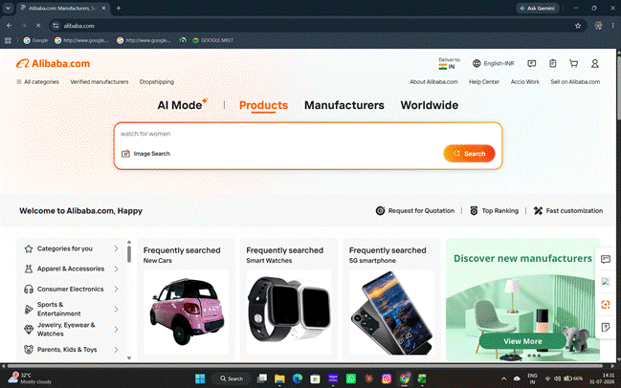
● Scenario ID: 1b
Scenario: Login with valid username, incorrect password
Test Steps:
1. Open the Online Shopping System login prompt
2. Enter Username
3. Enter Password
4. Submit / Click Login
Screenshots:
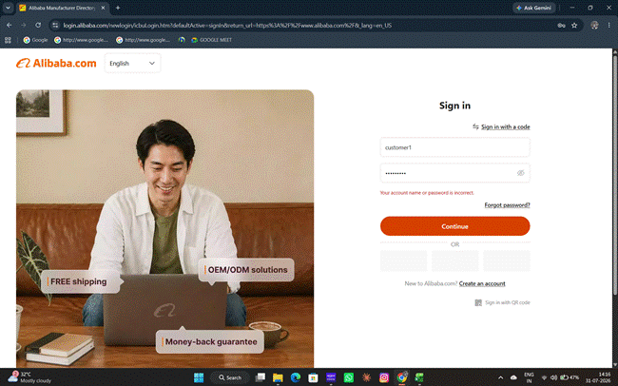
● Scenario ID: 1c
Scenario: Login with invalid username, valid password
Test Steps:
1. Open the Online Shopping System login prompt
2. Enter Username
3. Enter Password
4. Submit / Click Login
Screenshots:
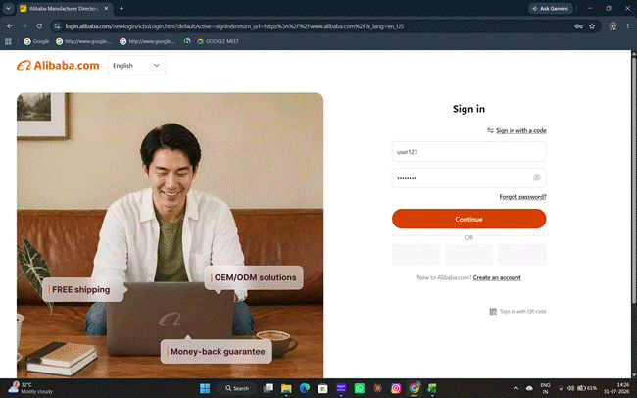
● Scenario ID: 1d
Scenario: Login with invalid username and invalid password
Test Steps:
1. Open the Online Shopping System login prompt
2. Enter Username
3. Enter Password
4. Submit / Click Login
Screenshots:
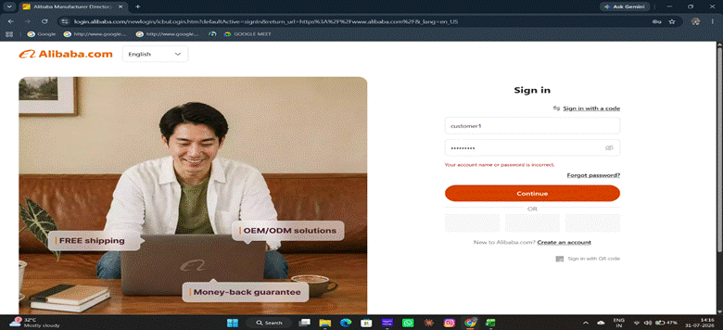
● Scenario ID: 1e
Scenario: Login with blank username, valid password
Test Steps:
1. Open the Online Shopping System login prompt
2. Enter Username
3. Enter Password
4. Submit / Click Login
Screenshots:
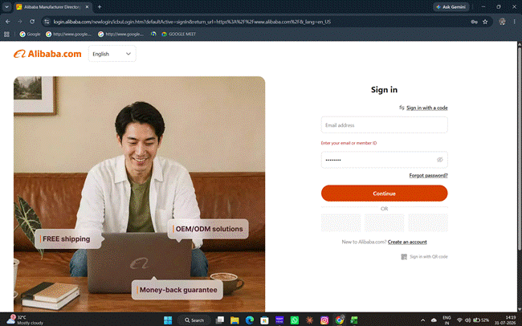
● Scenario ID: 1f
Scenario: Login with valid username, blank password
Test Steps:
1. Open the Online Shopping System login prompt
2. Enter Username
3. Enter Password
4. Submit / Click Login
Screenshots:
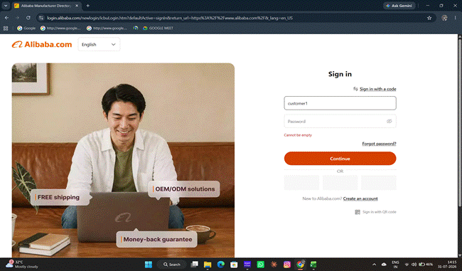
Scenario ID: 1g
Scenario: Login with blank username and password
Test Steps:
1. Open the Online Shopping System login prompt
2. Enter Username (blank )
3. Enter Password (blank)
4. Submit / Click Login
Screenshots:
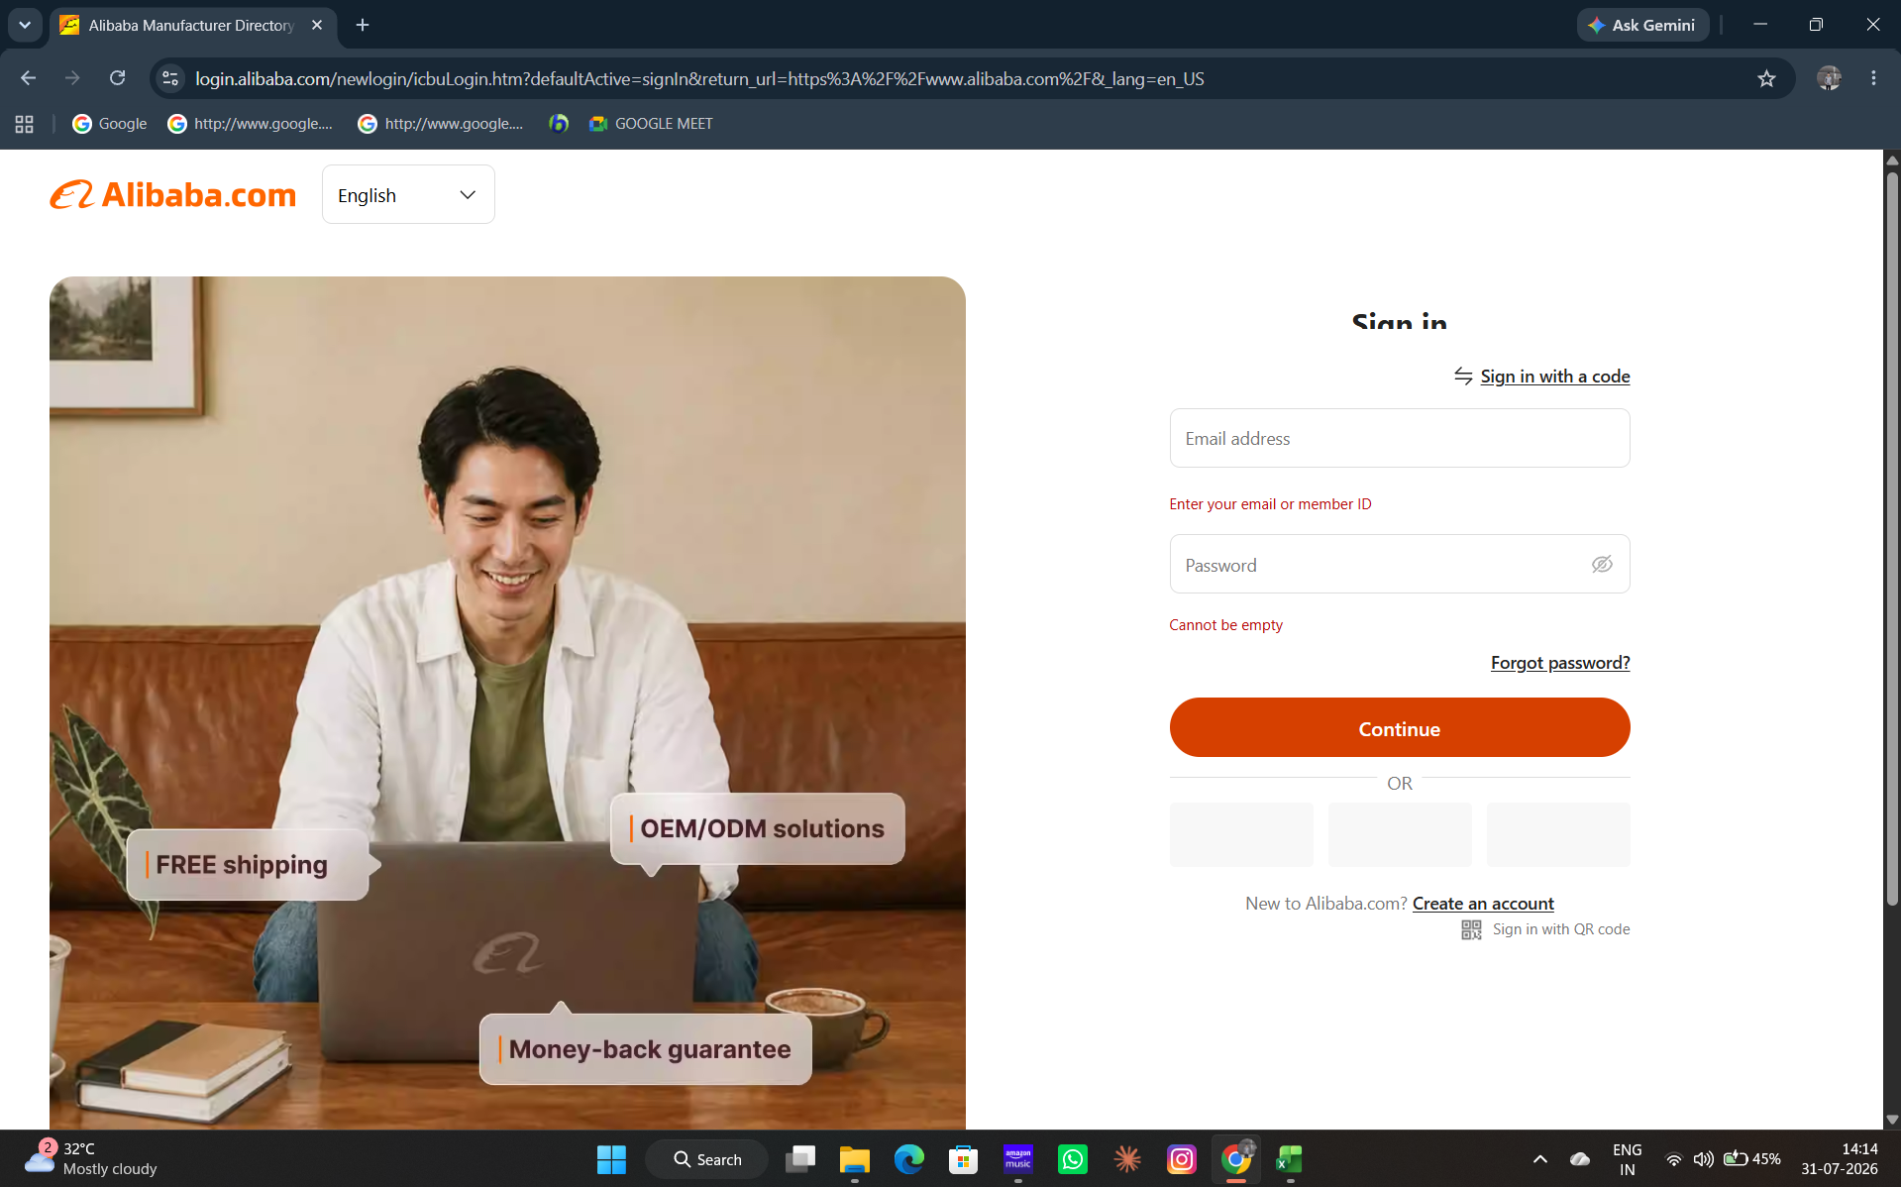
● Scenario ID: 1h
Scenario: Login with valid username containing extra spaces
Test Steps:
1. Open the Online Shopping System login prompt
2. Enter Username
3. Enter Password
4. Submit / Click Login
Screenshots:
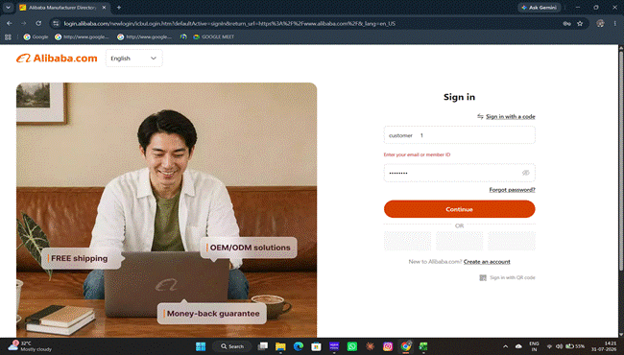

Summary of Test Results:
Total Test Cases : 8
Passed : 8
Failed : 0
Not Executed : 0
Pass Rate (%) 100%
Conclusion and Recommendations
Conclusion
All 8 test scenarios for the E-Commerce Website Login Module have been executed successfully with a 100% pass rate. The login functionality is working as expected across all test cases, including valid credentials, invalid credentials, and boundary conditions (blank fields, extra spaces). The actual results match the expected results perfectly, indicating that the Login Module is functioning correctly and reliably for the tested scenarios.
Test Coverage Analysis
• Valid credential authentication - PASSED
• Invalid credential rejection - PASSED
• Blank field validation - PASSED
• Input trimming/space handling - PASSED
• Error message accuracy - PASSED
• User session establishment - PASSED

Recommendations
• The Login Module is ready for deployment to production with the current functionality.
• Consider implementing additional security features such as rate limiting, account lockout after failed attempts, and CAPTCHA for enhanced protection.
• Add password encryption/hashing to ensure credentials are stored securely.
• Implement session timeout and secure session management protocols.
• Perform penetration testing to identify potential security vulnerabilities.
• Add logging and monitoring for login attempts for audit and security compliance.
• Test with additional scenarios including SQL injection attempts, XSS attacks, and brute force attempts.
• Conduct performance testing under load to ensure the login module scales appropriately.
• Implement two-factor authentication (2FA) for enhanced security.
• Regular security updates and maintenance should be scheduled.

Bug Reports
Summary: No bugs identified during the execution of the 8 test scenarios. All tests passed with expected results matching actual results.

